**Full Stack Development with MERN**

**Frontend Development Report**

|  |  |
| --- | --- |
| Date | 08/07/2024 |
| Team ID | SWTID1720194751 |
| Project Name | Project – Flight Booking App(Fly High) |
| Maximum Marks | 10 |

**Project Title: Flight Booking App(Fly High)**

Date: 08/07/2024

Prepared by: SWTID1720194751

**Objective**

The objective of this report is to document the frontend development progress and key aspects of the user interface implementation for the Flight booking App project.

**Technologies Used**

* **Frontend Framework:** HTML, React.js
* **State Management:** Server Side, Endpoints,
* **UI Framework/Libraries:** HTML, CSS, JS
* **API Libraries:** Axios:- GET,POST

**Project Structure**

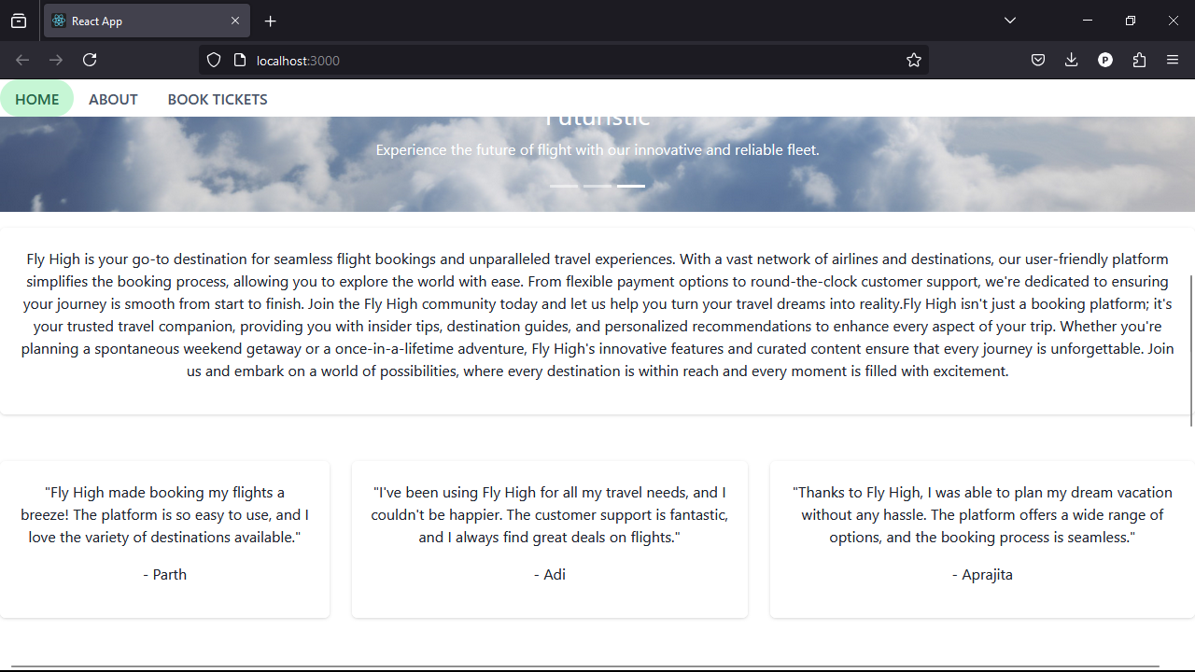

The frontend of our website encompasses of three things, Home, About and Book Tickets. At home, we can see the positives of the website, at About us column, you will be able to see the brief summary of the website, in book tickets, we can see the option for login and can proceed for the booking selection.

**Key Components**

1. **App.js**
   * Responsible for routing and main application layout.
2. **/components**
   * Contains reusable UI components used across the application.
3. **/pages**
   * Includes different pages for Web App.

**Routing**

Routing is managed using React Router. Here are the main routes:

* **/userpage** - Landing page of the application.
* **/dashboard** - Dashboard displaying user data and statistics.
* **/profile** - User profile management.

**State Management (If Applicable)**

State management is achieved using API.

**Integration with Backend**

The frontend communicates with the backend APIs hosted on [backend URL]. Key endpoints include:

* **GET /api/data** - Retrieves data for display.
* **POST /api/user/login** - Handles user authentication.

**User Interface (UI) Design**

* The UI design follows a basic White and Green design.
* Implemented using HTML, CSS.

**Third-Party Integrations (If any)**

--